ICE BOCCE RULES
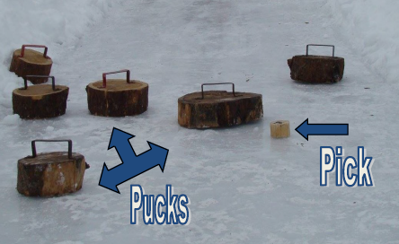
The object of the game is to slide your Ice Bocce Pucks closer to the Pick than the opposing team.
Playing Ice Bocce:
The game consists of 6 frames (down and back 3 times.) A frame starts with kicking the Pick by a team member toward the opposite end of the lane. The frame is complete after the Pucks have been slid and the points awarded.
Whoever wins the coin toss (using the Pick) will play first and will pick the color of their Pucks. If the Pick is kicked out of the lane on the opening kick-off it will be re-kicked. Pick must land past the halfway line.
Once the Pick is in position, the first team slides their Puck. Taking alternate turns, each team slides their Pucks toward the Pick to get their Puck closest to the Pick. You must release the Puck handle immediately once the Puck is on the ground.
No steps can be taken beyond the hole when tossing the Puck. Pucks must be released before the 10 foot line.
If the Puck is not lying flat or has any part off of the lane it will be removed from play. If the Puck goes in the hole it is in play regardless if it is lying flat or not.
In the event the Pick is kicked out of play during the match the other team will place the pick on the opposite side 10 foot line.
Scoring:
In each frame, only one team scores. One point is given for each Puck that is closer to the Pick than the opposing team’s Pucks.
To break a tie, one additional frame will be played.
Tournament:
Determine a team captain who will be responsible for turning in the team score after each game.
The Tournament starts as “Pool Play” with teams divided into groups of 4 teams. Each group of 4 teams will be assigned two lanes to play on.
Each team will play 3 games in the 4 team bracket they are placed in.
The top 2 teams will compete in a single elimination bracket and the bottom 2 teams will compete in a single elimination bracket. The top teams from each bracket will compete for the championship.
In the event a team needs a substitution for a player in any game, the opposing team shall agree on the substitute and the sub must sign a waiver in the tent.
Disputes that cannot be resolved by the two teams’ captains will be decided by the judge. Judges' decisions are final!
If a team does not show up for their slotted time in a timely manner they will forfeit the match.

